To set up an auto responder:

- Make sure that MS Word is not enabled as the email editor in Outlook.
- Select Tools → Options in the Outlook Menu:
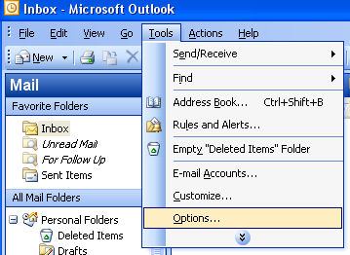

- Select the “Mail Format” tab and ensure that the “Use Microsoft Office Word 2003 to edit e-mail messages” is unchecked.
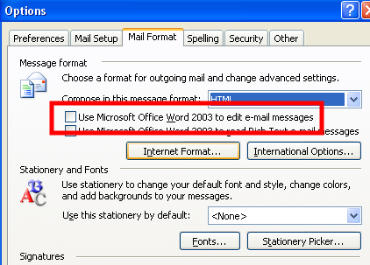

- Select the “Apply” / “OK” buttons to save / close this window.
- Start a new Message: Select the “New” button:
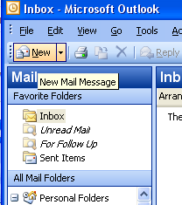

- Type the Subject and message of your auto-reply. Optionally, you can add Cc: and Bcc: recipients to send a copy of each automatic reply.
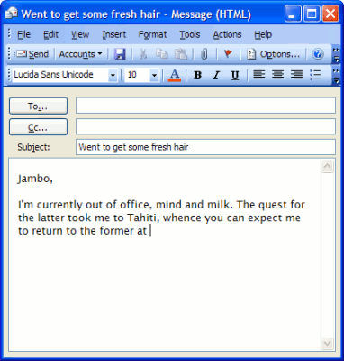

- Select File → Save As... from the menu.
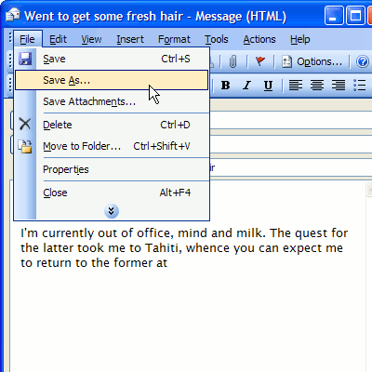

- In the save box, Give the message a name and make sure “Outlook Template” is selected under Save as type:

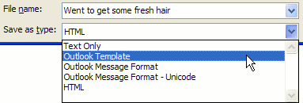

- Click Save.

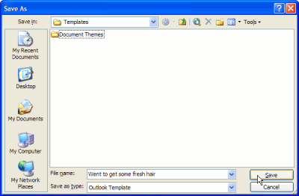

- Select Tools → Rules and Alerts... from the menu in the main Outlook window.
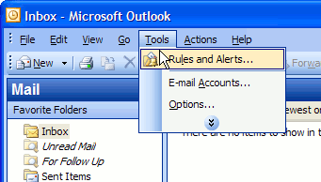

- Select “New Rule....”
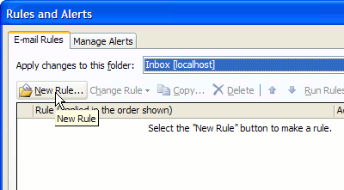

- Click Start from a blank rule.
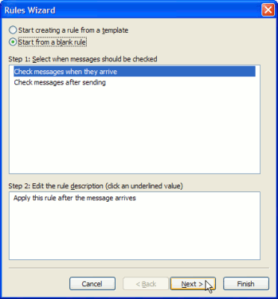

- Make sure Check messages when they arrive is selected.
- Click Next >.
- Check Where my name is in the To box under Select condition(s).
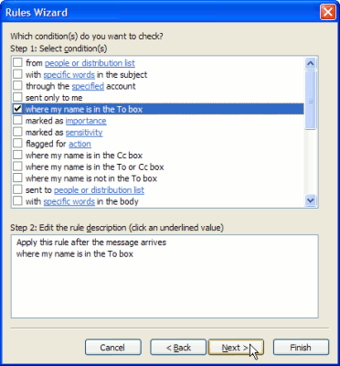

- Alternatively, you can leave all boxes unchecked to make the auto-responder reply to all incoming mail.
- Click Next
- Check reply using a specific template under Select action(s).
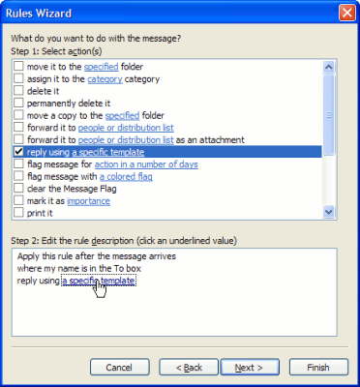

- Click on a specific template under Edit the rule description.
- Select User Templates in File System under Look In:.
- Highlight the template created before.
- Click Open.
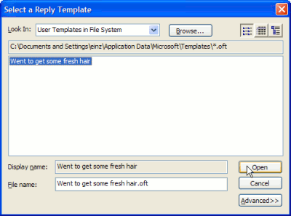

- Click Next >.
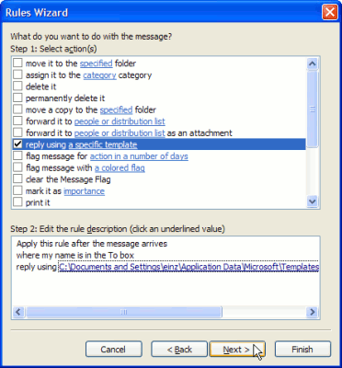

- Check Except if it is an Out of Office message under Select exception(s).
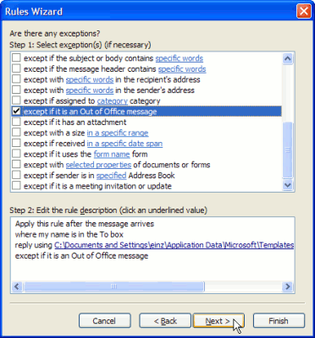

- Click Next >.
- Type the desired name for your auto-responding filter under Specify a name for this rule.
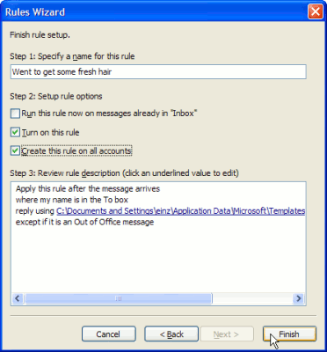

- Optionally, check Create this rule on all accounts.
- Click Finish.
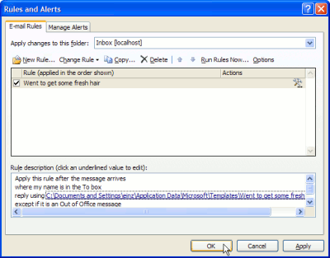

- Click OK.
- Test it out.

